UHC at home 6/14/20

Jesus shows us many ways we can serve and take of others. In many bible stories we see this demonstration of Jesus character including the story where Jesus washes his disciples’ feet. Jesus shows us that no matter how many bad choices we make He will always forgive us and wash us of our sins. You can read the story below or just read a few verses. When you are done reading as a family look at the pictures below and answer the questions together.

John 13: 12-17 or Read the whole story here: https://www.biblegateway.com/passage/?search=John%2013:1-17&version=NIV

¹² When he had finished washing their feet, he put on his clothes and returned to his place. “Do you understand what I have done for you?” he asked them. ¹³ “You call me ‘Teacher’ and ‘Lord,’ and rightly so, for that is what I am. ¹⁴ Now that I, your Lord and Teacher, have washed your feet, you also should wash one another’s feet. ¹⁵ I have set you an example that you should do as I have done for you. ¹⁶ Very truly I tell you, no servant is greater than his master, nor is a messenger greater than the one who sent him. ¹⁷ Now that you know these things, you will be blessed if you do them.

Activity: Look at the picture below of kids serving. What do you see? What do you notice? How can you serve others as Jesus served us? What kinds of things can you do to help siblings? Parents? Neighbors?
Challenge: Commit to helping someone else before yourself today or this week. Write it down and share with someone in your family. Be prepared to share how you served in kids chat next week. Link to additional writing activity: $1 https://www.teacherspayteachers.com/Product/Jesus-Washes-the-Feet-of-His-Disciples-Worksheets-4505918
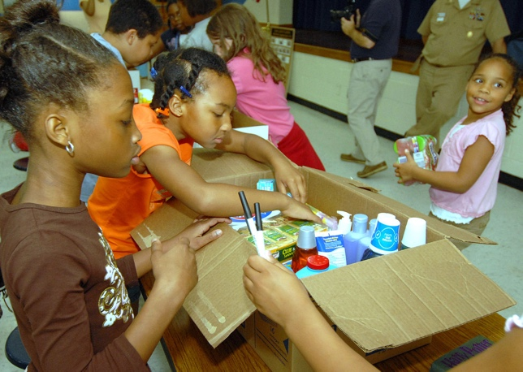
This Photo by Unknown Author is licensed under CC BY-SA

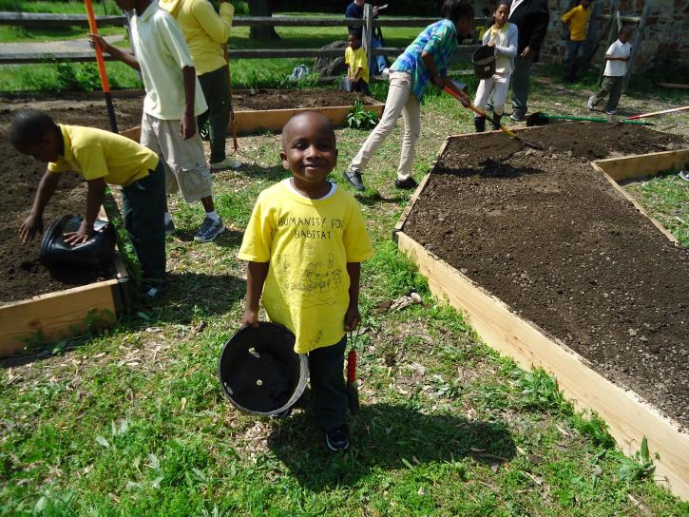

This Photo by Unknown Author is licensed under CC BY-NC-ND

